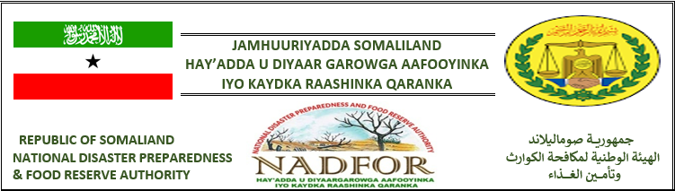

NADFOR Drought Early Warning - Monthly Bulletin Issued On 29th November 2021

A Drought Early Warning-Monthly Bulletin produced by NADFOR. This is the outcome of data collected by the regional teams led by coordinators of NADFOR, with the support of Village/ Community Disaster Risk Management Committees{CDRMC} and District officers of line ministries, who monitor the Key Early Warning Indicators. These EW-indicators include:
- Rainfall performance.
- Water availability and accessibility
- Pasture and browse conditions.
- Livestock body conditions
- Livestock migration pattern
- Milk availability.
- Outbreak of diseases
- Market conditions.
- Terms of trade.
- Environment Issues and uncertainty risk.

KEY-FINDIN

- Rainfall performance:
No rainfall was reported in the entire country of Somaliland in November 2021. Likewise, we all aware that the 2021 Deyr rainfall was below normal and short in duration. Rain was only received in the first 10 days of October and was totally ceased throughout the November.
- Water availability:
Water availability is currently near to normal level in the majority of the western and Eastern regions of Somaliland, but many areas in the eastern regions (Sanaag, Sool and Togdheer) are currently experiencing water shortage due to the 2021 Deyr rainy season failed. Nadfor teams conducted drought risk assessment in the first 10 day of November 2021,and covered all the six main regions of somaliland have found that about 700,000 people{ equivalent into 116,000HHs} have been thoroughly affected by current drought. Here is the total estimated number of affected households per region in the table below:
Total estimated number of Drought affected population in Somaliland
S/N | Region | Total number of affected population
S/N | Region | # of HHs in crisis | HHs in H E | Total of HHs
1 | Togdheer | 22,000 | 12,000 | 34,000
2 | Sool | 11,000 | 10,000 | 24,000
3 | Sanaag | 14,000 | 8,000 | 24,000
4 | Hawd of Marodijeeh | 17,000 | 0 | 17,000
5 | Coastal areas | 8,000 | 0 | 8,000
5 | >Sahil | 8,000 | 0 | 8,000
5 | >Awdal | 9,000 | 0 | 9,000
Total |  | 86,000 | 30,000 | 116,000 HHs

- Pasture condition:
At this time, Pasture conditions are average to below average level across the country except for Coastal areas of Awdal and Sahil regions and many districts of the eastern regions( sool, Sanaag and Togdheer) where are currently under pasture shortages due to devastating desert locust and insidious drought. These drought affected districts under the eastern regions include Burco, Duruqsi, Balley dhiig, Buuhoodle, Ceel-afweyn, Gar-adag, and south east of Sanaag, as well as Hawd zone of Lascaanood.

- Livestock body conditions:
All species of livestock rearing in the country are physically average to good and healthy due to those livestock have sufficient pasture and browse and fresh water.
- Livestock migration patterns:
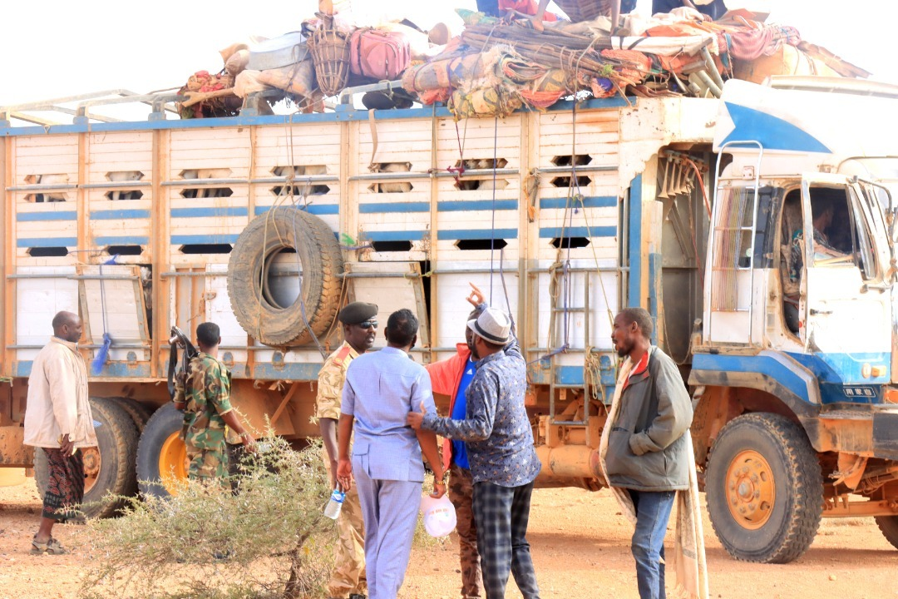
Currently livestock migration is generally confined to usual migration areas within the districts/or regions, although a huge number of in-migrated livestock from Puntland and Mudbug regions are crowded into the eastern parts of Somaliland, according to the NADFOr Regional Coordinators. In addition that there are a considerable fear of the in-migrated livestock may drastically increase pressures of water and pasture resources shortages as well as they may carry such contagious diseases to the hosting areas of Somaliland.
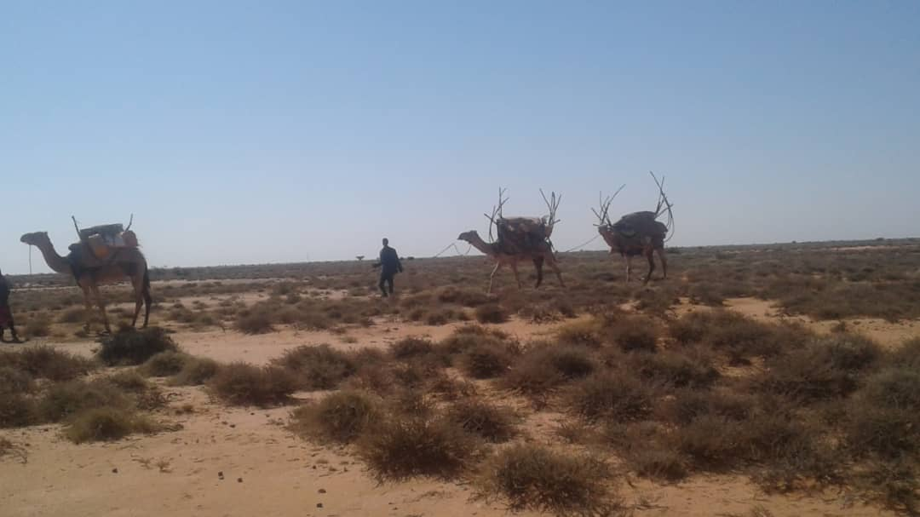
This lorry is carrying numerous heads of sheep and goats moved from Mudug and Puntland regions.
They are nomadic pastoral households moved from Hawd of Buuhoodle and Lascaanood in to the areas locally known as Nugal and sool pleatuex-zone under sool and sanaag regions.

- Milk availability:
Milk is available and is estimated at average level in the majority of the country.
- Outbreak of Diseases:
- Disease both human and animal: No disease outbreak of livestock was reported throughout the country but there is a re-emergence of Covid-19 pandemic disease and caused many deaths across the regions.
Re-emergence
- Market conditions:
- The price for local quality of camel was 4,500,000 sl.sh.
- The price for local quality of cattle was 2,990,000sl sh.
- The price for Local quality of Goat was 360 sl sh
- The price for 50kgs bag of Rice was 270,000 SL sh.
- The price for 50kgs bag of wheat flour was 230,000 sl.sh.
- The price for 50kgs/bag of sugar was 275,000 sl.sh.
- The price for 5litres of edible oil was 61,000 SL sh.
- Terms of trade :
Terms of trade were not in favor of pastoralists. For instance:
- In the visited areas under the drought affected districts, the income and purchasing power of the people is reduced by the deteriorated terms of trade and the high cost of water.
- To purchase 50kgs of rice about one shoat is required instead of the one shoat required to buy 50kgs of rice, 50kgs of wheat flour, 25 kgs of sugar and 3litres of edible oil in normal years. At present, one drum of 200ltres of water costs 40,000 SL sh ($4.7) against $1.00 per drum in normal years.
- Average price for camel could fetch 12 heads of goats

- Uncertainty issues:
- Pastoral communities with their livestock from Puntland and Mudug region in south Somalia in- migrated into the eastern parts of sool and Sanaag regions, according to the NADFOR regional coordinator.
- There is a re-emergence of Covid-19 pandemic disease that caused many deaths across the regions of Somaliland.

If you need further information, please Contact:
Ahmeddini Nur Goth
Director of Disaster preparedness and Early warning systems
Of NADFOR Authority:
Email: ahmedngoth@gmail.com
Mobile: 0634127474

