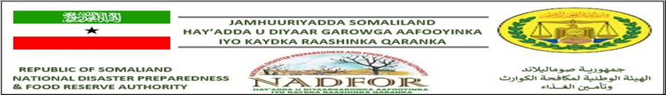NADFOR DROUGHT RISK ASSESSMENT REPORT
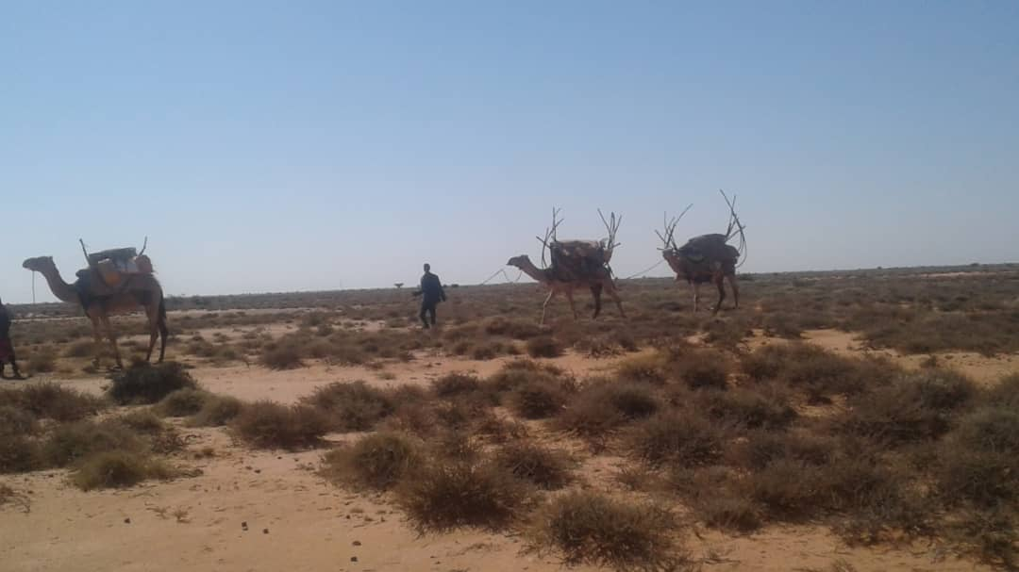
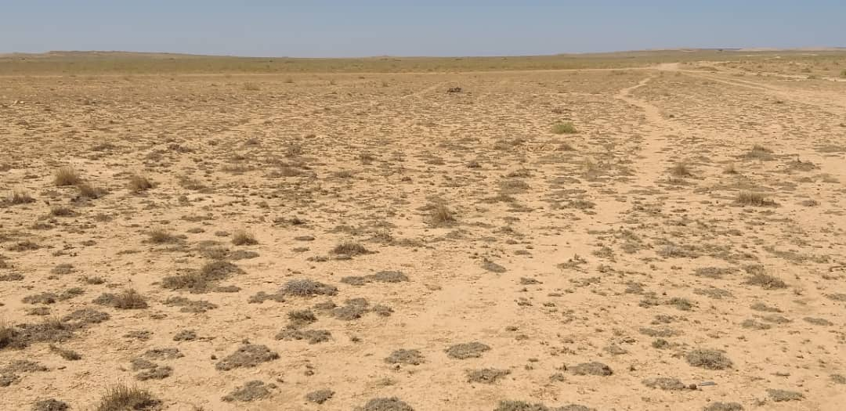
25th October-9th November 2021
- Introduction
The NADFOR Missions started on Thursday 25th October to 9th November 2021. All in all the field activities took for 14days.Two main mission teams were sent to different regions of Somaliland.
The first mission covered majority of the agropastoral and pastoral livelihood zones of Awdal, Marodijeeh and Sahil regions whereas the second mission covered large areas under eastern regions such as Togdheer, Sool and Sanaag regions. The missions have found that
Both NADFOR Missions have found that the 2021 Deyr rainfall was below normal and short in duration. Rain was only received in the first 10 days of October, according to regional coordinators of NADFOR. Several areas in the eastern regions of Sanaag, Sool and Togdheer are currently experiencing water and pasture shortages. Pastoral movements in search of pasture and water have been reported from nearly 20 villages, including Duruqsi Village in Togdheer Region, towards the Somali region of Ethiopia. NADFOR estimates that about 700,000 people as equivalent into 116,000HHs living in the assessed areas of all six main regions of somaliland.
Currently 82,000HHs living in sool, Sanaag and Togdheer need water trucking. Nutrition partners have reported emerging gaps in nutrition services in three villages (Garadag, Huluul and Ceel-Cade) in Sanaag and Sool regions.Here is the total estimated number of affected households per region or zone shown in the table below:

Total estimated number of Drought affected population in Somaliland
S/N | Region | # of Drought and locust affected people
S/N | Region | # of Households | #Total number of affected people
1 | Togdheer | 34,000 | 204,00
2 | Sool | 24,000 | 144,000
3 | Sanaag | 24,000 | 144,000
4 | South of Marodijeeh | 17,000 | 102,000
5 | Coastal areas of  Awdal and Sahil | 17,000 | 102,000
Total estimated number of HHs |  | 116,000HHs | 700,000

- The mission reported current situations of the assessed areas as below::
It is worth noting that the disasters( drought and locust ) affected the regions in various ways, for instances, the eastern regions complained about seriousness of water shortage whereas the communities in the coastal areas of Sahil and Awdal regions and those in the Hawd zone of Marodijeeh are currently faced under pasture shortage. But water and pasture are currently available in the majority of the other livelihoods (Golis ranges and agropastoral and pastoral livelihoods) of the Western regions because of the 2021 Karan rainfall which was estimated at average to below level occurred in these zones.

  - Sool region
Generally, the mission team has covered large areas including drought affected districts : Lascaanood, Hudun, Taleex and Hawd zone of Las-caanood. The failure of the Deyr season usually results prolonged dry season and drought sometimes. This year the deyr rainy season was not good and Berket owners have not harvested it well the meager available rains.
The finding of the team was severe water shortage; this was assisted by drop down to the livestock market and the price of food, which was increased much. Nomadic people cannot afford to buy the expensive water, which is about3.5$ per Barrel.
The mission prioritized the needs as following:
- Water trucking
- Water trucking and water treatment for Water treatment with filtering, chlorination and water tablets.
- Establishment of water management committees.
- Rehabilitation construction of shallow wells.
- Rehabilitation of existing strategically located boreholes.
- Distribution of water storage.
- Improvement to the hygiene and sanitation.
- Education:
- Closely monitor the nomadic communities in the drought affected locations for fearing of food shortage.
- School feeding programmed must continue
- To establish feeding program centres for those Schools without feeding programmes.
- Follow-up needs to be done by ministry of education supervisors and regional coordinators.

  - Sanaag region:
The team assessed many villages and settlements under the drought affected districts such as Elafweyn, Gar-adag, and east South of Sanaag region. The mission observed that shortage of water is current major problem in the assessed areas of sanag region. They started water trucking and one barrel cost 3.5$. Poor people cannot afford to pay for it.
The Team recommended the following interventions:
- Water trucking
- Water trucking and water treatment for Water treatment with filtering, chlorination and water tablets.
- Establishment of water management committees.
- Rehabilitation construction of shallow wells.
- Rehabilitation of existing strategically located boreholes.
- Distribution of water storage.
- Improvement to the hygiene and sanitation.
- Education:
- Closely monitor the nomadic communities in the drought affected locations for fearing of food shortage.
- School feeding programmed must continue
- To establish feeding program centres for those Schools without feeding programmes.
- Follow-up needs to be done by ministry of education supervisors and regional coordinators.
  - Togdheer region:
The mission assessed many villages and settlements which were seriously affected by the drought situation because of the failure of the 2021 Deyr season. The drought affected districts which are mostly located in the hawd zone of Burco (include Burco, Duruqsi, Balley dhiig…).
The shortage of water is similar to the other regions in every aspect. The major water sources of the areas are Berkets and Dams but they dried up and water trucking has already started. The cost of the water increased much (4.5$) and the poor people cannot afford.it is also difficult to the nomadic communities as they use most of the income for livestock watering. This reduced much their purchasing power for food and hence malnutrition and diseases are fear especially for children, lactating mother, pregnant and aged people. The mission prioritized the needs as following:
- Water trucking
- Water trucking and water treatment for Water treatment with filtering, chlorination and water tablets.
- Establishment of water management committees.
- Rehabilitation construction of shallow wells.
- Rehabilitation of existing strategically located boreholes.
- Distribution of water storage.
- Improvement to the hygiene and sanitation.
- Education:
- Closely monitor the nomadic communities in the drought affected locations for fearing of food shortage.
- School feeding programmed must continue
- To establish feeding program centres for those Schools without feeding programmes.
- Follow-up needs to be done by ministry of education supervisors and regional coordinators.

  - Coastal and subcoastal areas under Awdal and Sahil regions:
The fourth Trip started in the coastal areas under the both regions. The Team have not observed any water shortage problems but pasture for the livestock was scarce.
The finding of the team was severe pasture shortage; this brought about dropping down to the livestock market and price of food which was increased much, so nomadic people cannot afford to buy the expensive food. This reduced much their purchasing power for food and other NFIs, hence malnutrition and diseases are fear especially for children, lactating mother, pregnant and aged people.
The team recommended the following:
- EDUCATION:
- Closely monitor the nomadic communities in the drought affected locations for fearing of food shortage.
- School feeding programmed must continue
- To establish feeding program centres for those Schools without feeding programmes.
- Follow-up needs to be done by ministry of education supervisors and regional coordinators.
- Health/Nutrition:
- Strengthen surveillance and pre-position medical supplies and nutrition inputs in the drought stricken areas.
- Protection:
- Reinforce protection monitoring owing to The impact of droughts on vulnerable households required close monitoring
  - Hawd Zone Of Marodijeeh Region:
The last Trip started in the Hawd zone of Marodijeeh region. The Team have not observed any water shortage problems but pasture for the livestock was scarce.
The finding of the team was below average pasture and browse. It is advisable to closely monitor the nomadic communities in the Hawd zone of Marodijeeh region for fearing of water shortage in the coming months. The Mission prioritized the needs as following:
- School feeding programmed must continue
- To establish feeding program centres for those Schools without feeding programmes.
- Follow-up needs to be done by ministry of education supervisors and regional coordinators.
- Education:
- Strengthen surveillance and pre-position medical supplies and nutrition inputs in the drought stricken areas.
- Protection:
- Reinforce protection monitoring owing to The impact of droughts on vulnerable households required close monitoring

- Current Food Security in the Assessed Locations
In normal years, own livestock production (Milk, ghee and meat) and cash purchases are the main means of acquiring food, but own livestock production drastically reduces or depletes in the dry season.
Livestock sales and remittances from family members elsewhere are the main sources of income. Expenditure during a normal year is purchase of food, clothes and other minor needs. In addition, purchase of water is frequent in the dry season costing $3-$4.5 per drum of 200lires.Currently, Gifts and loans are the most important coping strategies
In the visited areas, the income and purchasing power of the people is reduced by the deteriorated terms of trade and the high cost of water. To purchase 50kgs of rice about one shoat is required instead of the one shoat required to buy 50kgs of rice, 50kgs of wheat flour, 25 kgs of sugar and 3litres of edible oil in normal years. At present, one drum of 200ltres of water costs $4-$ against $0.5-$1.00 per drum in normal years.
  - Coping strategies adapted before the external intervention.
Community usually have their own coping mechanisms and strategies to adapt the adverse impact of hazards before the external intervention. This commitment mainly come household’s through using their available resources. Usually the community has many coping strategies which directly linked with indigenous knowledge. the following points are the most common coping mechanisms and strategies which were practiced by the communities in the visited areas:
- Selling more of livestock than normal time.
- Reduce number of meals.
- Reduce non-essential household expenditures.
- Rely on inexpensive food.
- Animal migrations.
However, if the assistance for water shortage is carried out by the mandated organizations or if it rains, the people will save the money for water trucking and will be able to purchase food though food prices are extremely high.
But, if it does not rain and the assistance for water trucking will not take place, the people will spend most of their income to buy water. So, they will not be able to purchase food and will need immediate food assistance.

If it is necessary for further information,don,t hesitate and feel free to Contact
Ahmeddini Nur Goth
Director of Disaster preparedness
and
Early warning systems Of NADFOR Authority:
Email: ahmedngoth@gmail.com
Mobile: 063412747
------------------------------------------------------

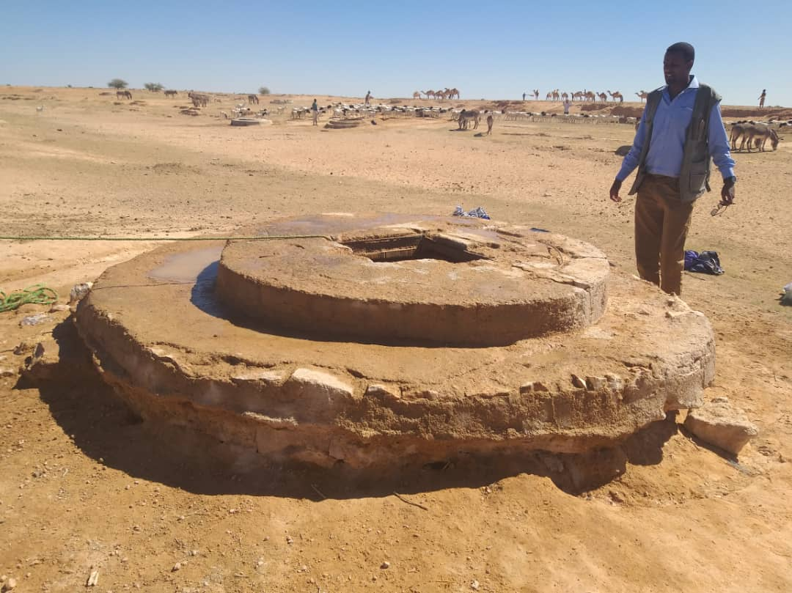
Fadhi-gaab water well

Drought affected areas in Ceelo-afweyn

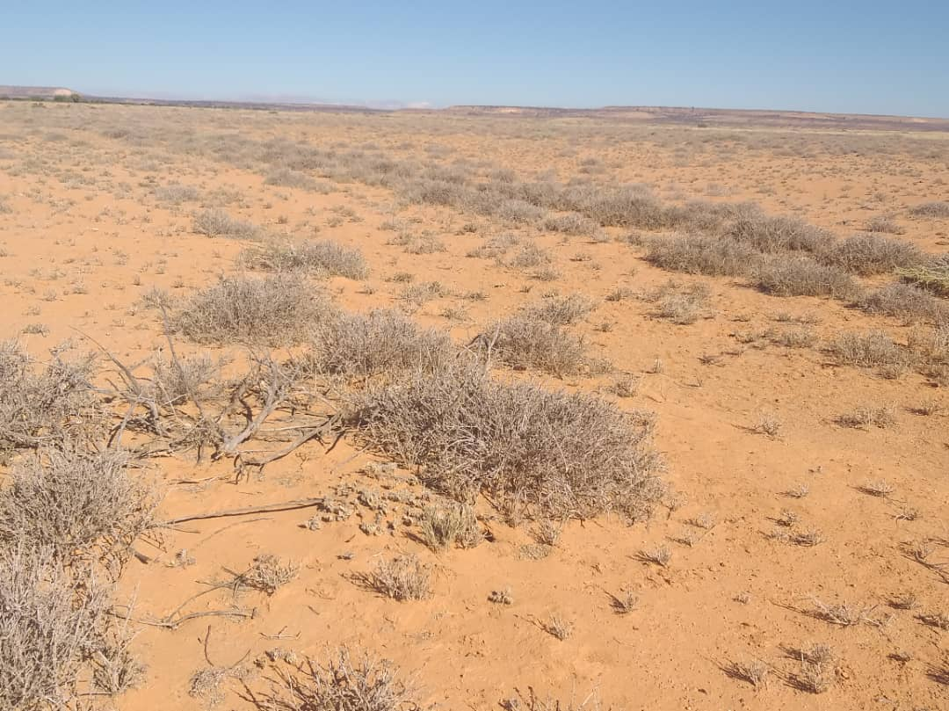
Bancadde in Eelafweyn

