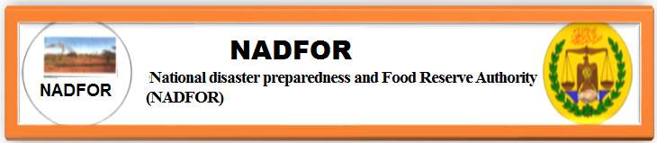

NADFOR-MEWS-MONTHLY-BULLETIN ON SANAAG REGION
0n 29th October 2021

NADFOR Produces Drought Monthly Bulletin in Collaboration with Shaqodoon through Funding of Oxfam. This drought monthly report is collected by CBDRM-committees with support of focal persons, who monitor key indicators of drought early warning. Targeting villages: Balanbaal, Ceelcadde, Dhoomo, Il-Libaah, Huluul, Faraguul, Dhoobo-Cantuug, Gawseweyne, Shiisha and Tuur-B.
The Key Early Warning indicators include:
- Rainfall,
- Water level
- Pasture Availability,
- Market condition and Terms of trade
- Emergency message recorded

Weather patterns and seasonal calendar in the country

Four main seasons characterize the seasonal weather patterns in Sanaag region as in the case of other [parts of the country: Two rainy seasons and two dry seasons.

The seasons are largely determined by shifts in wind patterns from Indian Ocean (a southerly air stream) and from Asia and Arabia(north-easterly winds) .The main rains fall during the Gu-season(April-June) with lighter and more sporadic rains falling during the Deyr season ( October –December).

Rainfall levels during these two seasons determine water and pasture availability for livestock ,and as a result, animal body conditions ( and value),reproductive rates and milk availability.
In other words, there are two dry seasons which are characterized by one shorter, cooler season, known as the Hagaa (22nd July to 23rd September and a long, hot dry season, known as the Jilaal (January to 23th March), which is the harshest season of the year. During the dry season, livestock migrate to areas where better water and pasture are still available.

In addition to these four main seasons, particular weather systems occur of the country. The western regions of Somaliland receive Karan rains between July and August, which allow agro-pastoralists to practice a karam harvest.

Guban coastal strip receives Xays rains during the colder months of December and January, attracting pastoralists from high land areas (Agropastoral and Golis mountainous zones) to the coast as pasture improve.

KEY-FINDINGS
- Rainfall performance:
In generally speaking, Eastern regions of Somaliland are currently in short rainy season locally known as Deyr season. The Deyr rainy season usually starts from 23rd September to 22nd December. About 70% of the MEWS targeting districts such Elafweyn and Gar-adag received average to below rainfall. these areas include Huluul,Illibaah,Dhoomo,Balanbaal,and Ceelcadde villages whereas Faraguul,Dhoobocantuug,Gawseweyne,Tuurciyaal and Shisha expects to obtain rain within the coming weeks of October 2021.
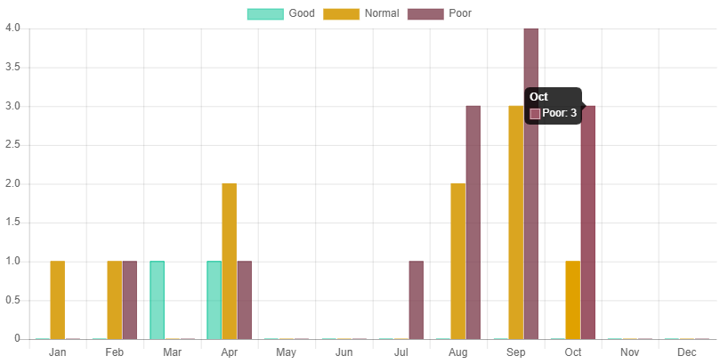
Figure 1: Rainfall

Rain finger2
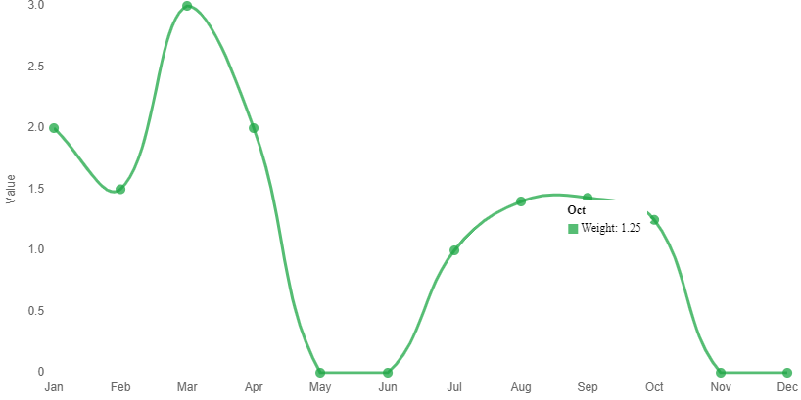
Weight Per Month is very poor and estimated at below average

- Water availability:
Water availability is near to average levels. The field monitors reported that 55% percent of the MEWS areas ‘water availability is normal whereas the remains 45% is at below average as the figure water level below shows us.
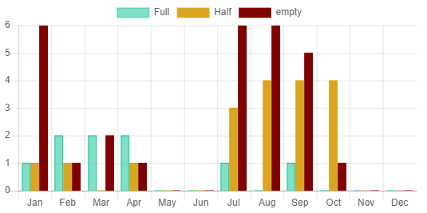
Figure 2 :Water Level

Figure 2: water level
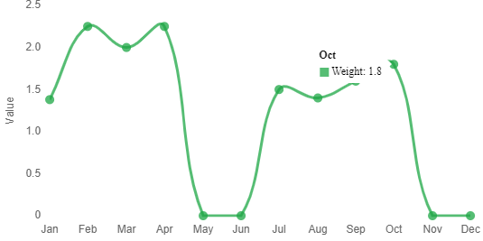
Weight Per Month shows water level is near to average.

- Pasture conditions:
Pasture is available and is estimated at average level due to 70% of MEWS targeting areas received average to below average rainfall during October 2021. Even though the remaining 30% has received below average level of rainfall in October 2021.
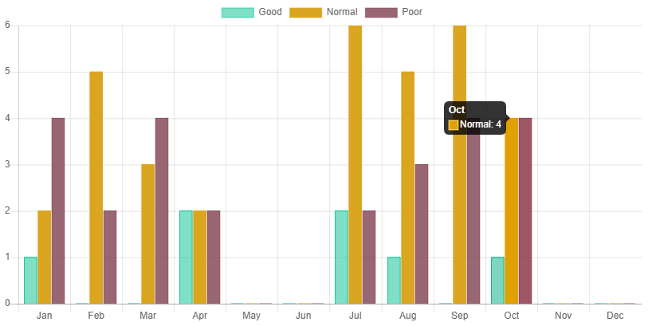
Figure 3: Pasture condition:

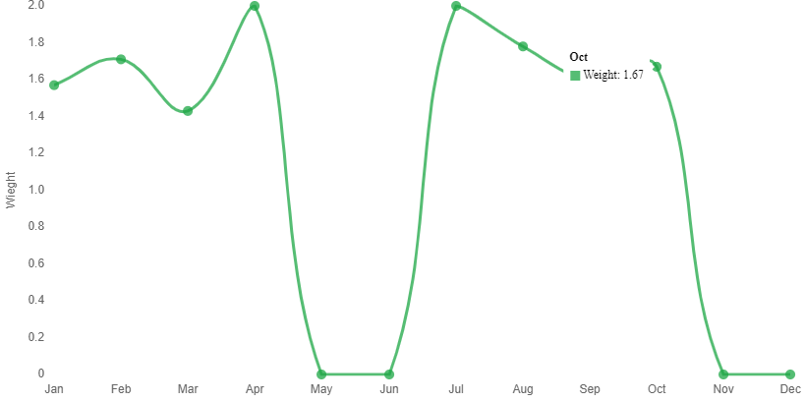

Weight Per Month shows pasture condition is at average level, currently.

- Market conditions:
- The Price of local quality of goat was 460,0000 sl
- The price for local quality of camel was 4,100,000sl.sh. 4,450,000sl.
- The price for 50kgs/bag of sugar was 285,600 sl sh .
- For 50kgs bag of Rice was. 277,100 sl slsh
- For 50kgs bag of wheat flour was 210,000 sl.sh.
- While the price for 5litres of edible oil was 50,000 SL sh.

Figure : Camel and Goat-price
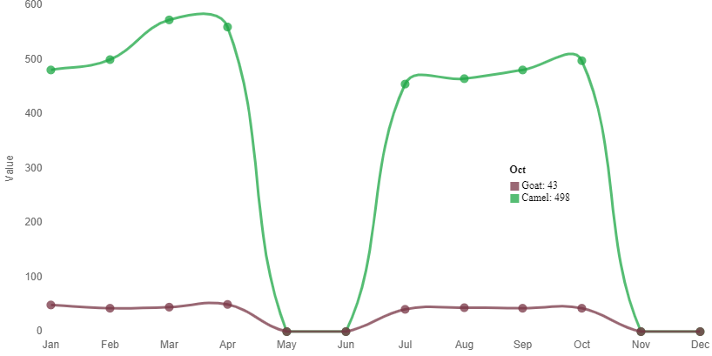

This system shows comparison of camel and Goat –price in kind of US
Figure : comparison of Rice and Sugar price
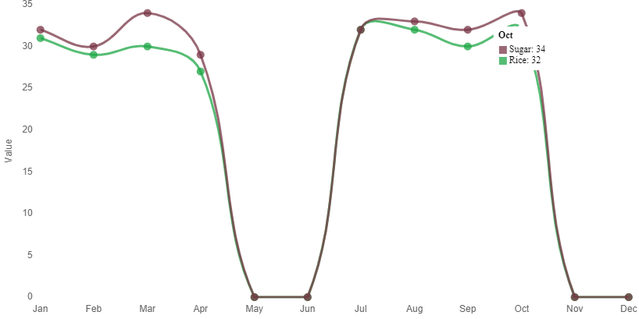

This figure shows comparison between Sugar and Rice –price in kind of USD.

- Terms of trade :
Terms of trade were in favor of pastoralists. For instances,
- Average price of a goat could fetch 50kgs of Rice and 50kgs of sugar and 5liters of Edible oil during the October 2021.
- Price for local quality camel could fetch about 10 heads of shoats( sheep/goats)

If you need further information, please Contact:
Ahmeddini Nur Goth
Director of Disaster preparedness and Early warning systems
Of NADFOR Authority:
Email: ahmedngoth@gmail.com
Mobile: 0634127474

