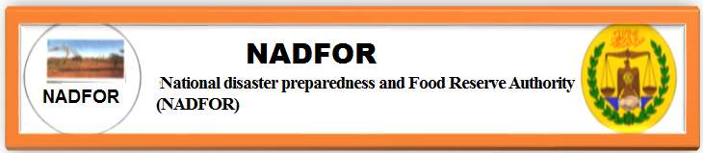

Nadfor Drought Monthly Bulletin Issued On 30th September 2021

A Drought Monthly Bulletin produced by NADFOR. This is the outcome of data collected by the regional coordinators of NADFOR, with the support of Village/ Community Disaster Management Committees, and District officers of line ministries, who monitor the Key Early Warning Indicators. These EW-indicators include:
- Rainfall performance.
- Water availability and accessibility
- Pasture and browse conditions.
- Livestock body conditions
- Livestock migration pattern
- Milk availability.
- Outbreak of diseases
- Market conditions.
- Terms of trade.
- Environment Issues and uncertainty risks

KEY-FINDIN

- Rainfall performance:
Rainfall performances of this month are average of all regions except some parts of the Sanaag region (Elafweyn and Garadag districts), and sool region. Th e 2021 deyr rainfall is expected in the eastern regions of Somaliland.

- Water availability:
Water availability is currently at average level in the majority of the country due to the good performance of rainfalls.

- Pasture condition:
Pasture and browse conditions are at average level in the majority of the country except some parts of /district of the eastern regions (Sanaag, sool and Togdheer). But it is expected to get good rainfall of deyr season soon. Although desert locust swarms severely affected all agropastoral and pastoral areas of the country in general.

- Livestock body conditions:
All species of livestock rearing in the country are physically average to good and healthy due to pasture and browse improved
- Livestock migration patterns:
Currently livestock migration is generally confined to usual migration areas within the districts/or regions.
- Milk availability:
Milk is available and is estimated at average level in the majority of the country.
- Outbreak of Diseases:
No disease outbreak of livestock was reported throughout country but there has been a resurgence of Covid19, Pandemic Disease That caused many deaths across the regions of the country.

- Market conditions:
- The Price of local quality of goat was 500,000sl
- While the price for local quality of camel was 4,859,583, sl.sh.
- The price for 50kgs/bag of sugar was 240,000 sl.sh.
- For 50kgs bag of Rice was 241,000 sl sh.
- For 50kgs bag of wheat flour was 220,000 sl.sh.
- While the price for 3litres of edible oil was 39,900 SL sh.
- Price for one liter of camel milk was 50,000sl sh

- Terms of trade :
Terms of trade were in favor of pastoralists. For instance:
- Average price for a goat could fetch 50kgs of Rice, 25kgs kgs of sugar, 30kgs of w/flour and 6liters of edible oil during September 2021.
- Average price for camel could fetch 10 heads of goats

- Uncertainty issues:
Rainfall with Ferocious winds hit and seriously impacted on the following villages on 27th September 2021.
- Daray-godle village under Sahil region, rainfall with ferocious winds damaged 14 buildings, mainly composed of Houses, Teashops and shops and Daray Godle School. No injuries and loss of lives were reported at all.
- Abdaal village :
- A young girl who had been swept away by flooding water was found dead
- 27 irrigation farms were wiped out, Nadfor regional coordinator said.
- Primary and elementary school roofs were remove off by strong wind.
- Unidentified number of Sheep/goats and camels were swept away by flooding water
- 12 houses collapsed
- Lafaruug: Ferocious winds removed off the roofs of Lafaruug- school and 10househoueses
- Xabaalo Tumaal-village: Six huts collapsed.
All the negative impacts in the above was reported by the NADFOR Coordinator of Sahil region
- A/kadir, Jidhi, Kalawle and Beeya-garaca villages, rainfall with strong winds removed off corrugated sheets and roofs from schools and bed rooms of the students. In A/kadir, 2class rooms and 2bedrooms collapsed. As in the case of Sahil, loss and injuries of human lives and livestock were no reported. NADFOR coordinator of Awdal region reported.

Compiled By:
Ahmeddini Nur Goth
Director of Disaster preparedness and Early warning systems
Of NADFOR Authority:
Email: ahmedngoth@gmail.com
Mobile: 0634127474

N.B: see thatched with Images of winds affected buildings’

Sahil region
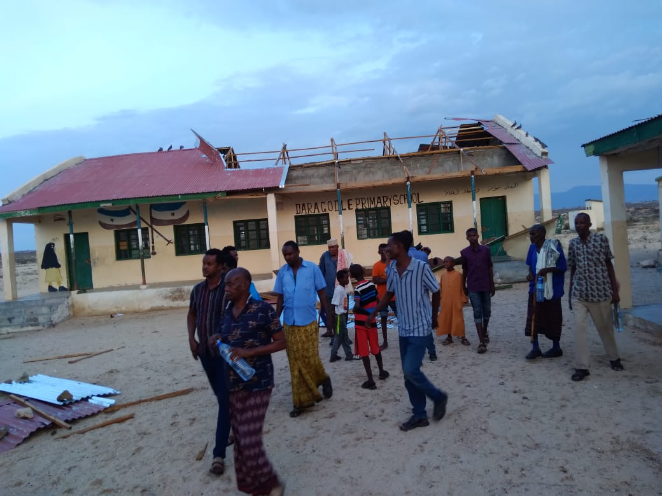
Daraygodle-school
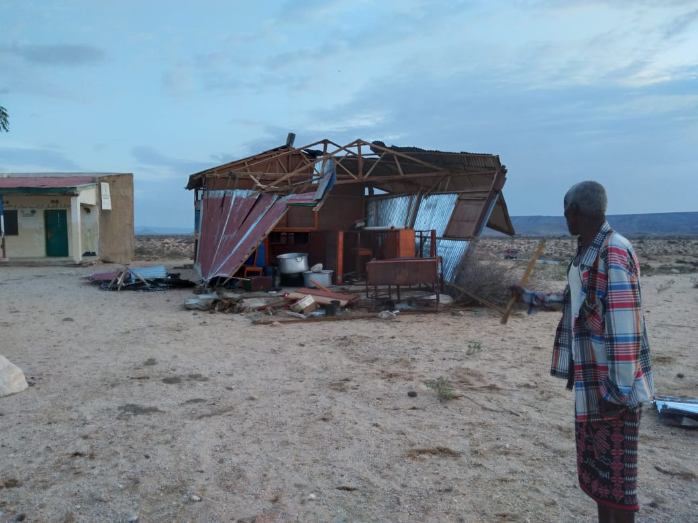
Daraygodle Kitchen of the school

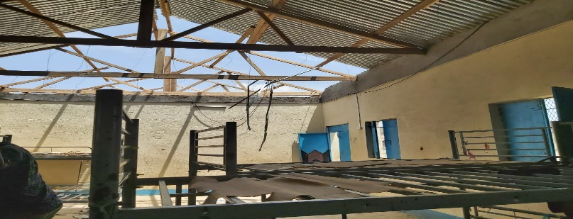
Awdal region:

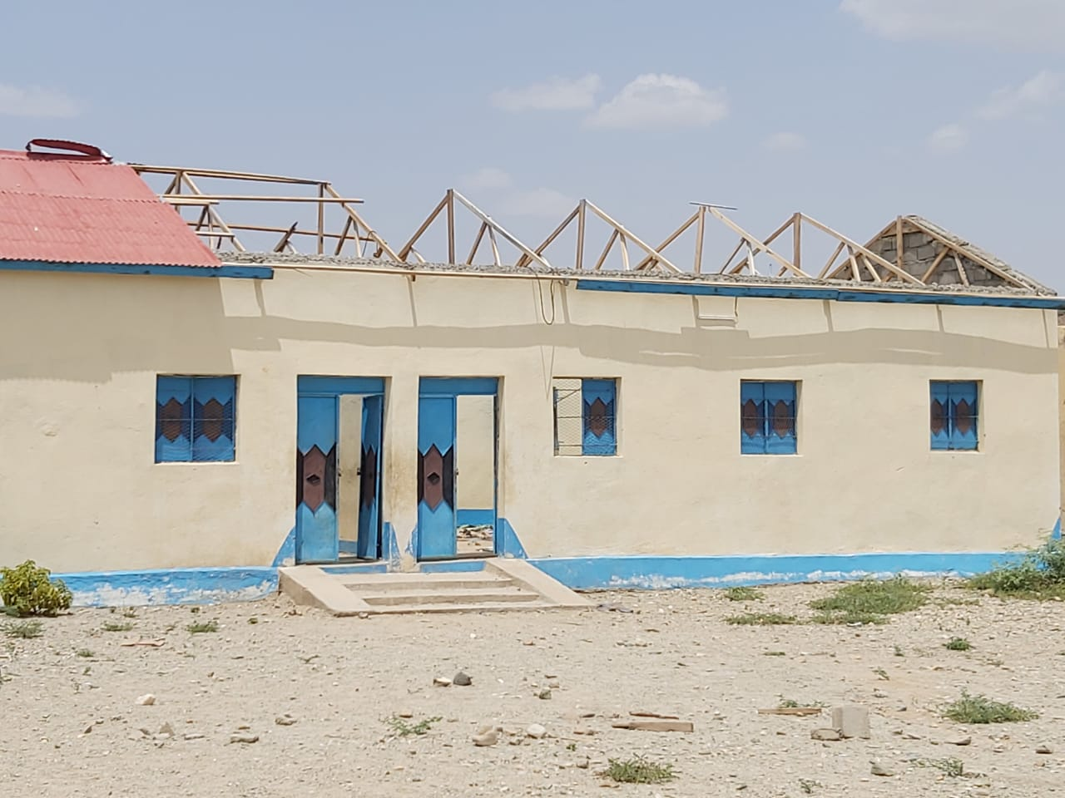
Jidhi school
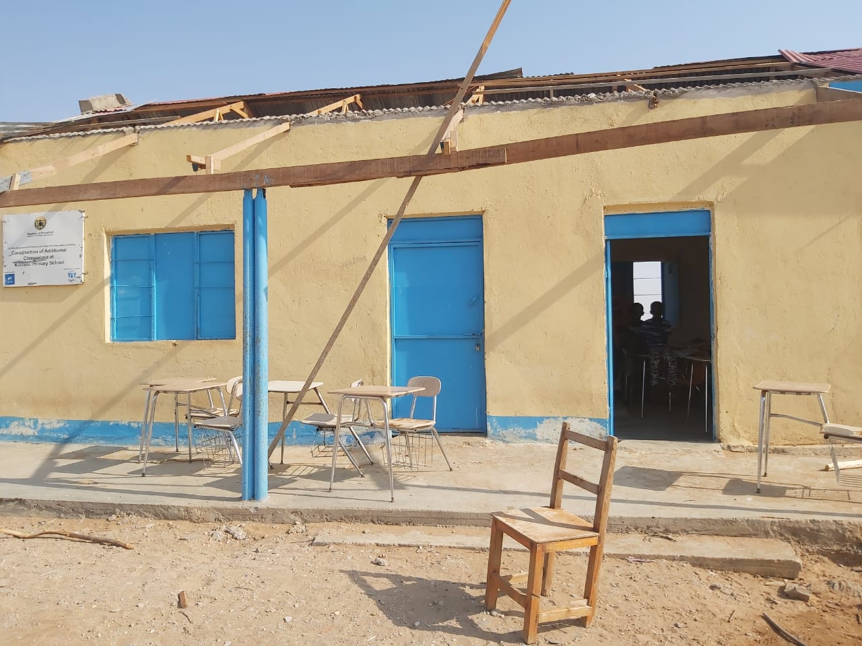
Kalawle school


